VALUATION SURVEY REPORT

OF

Land & Building.

Original COPY
Head OFFICE

SUBMITTED TO.

---------Bank Limited.
--------- Branch.
Din Complex, Kodomtoli Moor, Shuvadda, P.S.-Keranigonj, Dist.-Dhaka.

Owned By | Md Janal Abedin & Nasrin Akter.
Borrower | (i) Md Janal Abedin & (ii) Nasrin Akter.
Survey conducted by | M.K.B Survey & Poridarshok Co.
Report No | MKBSP/NRBC/2023/116.
Report Date | 03.09.2023.
Valuation Date | 01.08.2023.
M.K.B Survey & Poridarshok Co.
Khan Plaza, 205/4, 8/A (Lift-06), Culvert Road, Motijheel C/A, Dhaka.
Contact Number: 01911-975512, 01750-165792, 01922-666863.

SUMMARY OF VALUATION

Summary of Property Valuation:
S.L. No. | Type of  Property | Total Land/ Building. | Rate  In Tk. | Present Market Value | Forced Sale  Value -80%
A | Residential High Land. | 7.00 Decimals | 10,00,000.00  Per decimal | Tk. 70,00,000.00 | Tk. 56,00,000.00
A | 07 Storied Residential Building. |  |  | Tk. 2,31,82,000.00 | Tk. 1,85,45,600.00
Total Taka |  |  |  | Tk. 3,01,82,000.00 | Tk. 2,41,45,600.00
Present Market Value In Words: Three Crore One Lac Eighty Two Thousand Taka Only.
Distress Value In Words: Two Crore Forty One Lac Forty Five Thousand Six Hundred Taka Only.

01. | Name of the Account/Client: |  |  |  | Md Janal Abedin & Nasrin Akter.
01. |  | Account No: |  |  | As Per Bank Record.
01. |  | TIN No: |  |  | (i) 18670050---
01. |  | VAT Registration No: |  |  | N/A.
01. |  | BIN No: |  |  | N/A.
SL No. |  | Ward No. | Date of Issue |  | License No. | Renewal Year
N/A. |  | N/A. | N/A. |  | N/A. | N/A.
02. | Name of the Borrower: |  |  | (i) Md Janal Abedin & (ii) Nasrin Akter.
02. |  | Fathers Name: |  | (i) Late Mannan Bepari, (ii) Ali Akbor Hawlader.
02. |  | Mothers Name: |  | (i) Rezia Begum, (ii) Jahanara Begum.
02. |  | TI N No: |  | (i) 186700502---, (ii) 195126184---
02. |  | National ID No: |  | (i) 061692372----, (ii) 061692372---
02. |  | Date of Birth: |  | (i) 02.01.1983, (ii) 25.06.1988.
03. | Address of the Borrower.
03. |  | Permanent Address: |  | At Village-Shologhor, P.S.-Muladi, Dist.- Barishal.
03. |  | Present Residence. |  | At Holding No# 282/2, Modina Nagor (2 No. Golli), Village-Vangna, Kalindi Union Council (Word-03), P.O.-Brammonkitta, P.S.- Keranigonj, Dist.-Dhaka.
03. |  | Business Address: |  | N/A.
03. |  | Factory Address: |  | N/A.
03. |  | Goodown Address: |  | N/A.
03. |  | Telephone No: |  | N/A.
04. | Purpose of Loan. |  |  | Home Loan.
05. | Nature of Business. |  |  | N/A.

Proposed Mortgaged Land & Building.
06. Particulars of the Properties.
i. | Type of the Property: |  |  |  |  |  |  |  |  | Saf- Kabala.
ii. | Owner of the Property (As per Deed):
iii. | a) |  | Name: |  |  |  |  |  |  | Md Janal Abedin.
iii. | b) |  | Fathers Name: |  |  |  |  |  |  | Late Mannan Bepari
iii. | c) |  | Mothers Name: |  |  |  |  |  |  | Rezia Begum.
iii. | d) |  | National ID No: |  |  |  |  |  |  | 0616923727---
iii. | e) |  | Relationship with Borrower: |  |  |  |  |  |  | Borrower themselves.
iv. | Schedule of the Property.
iv. | Land Address |  |  | At Holding No# 282/2, Modina Nagor (2 No. Golli), Village-Vangna, Kalindi Union Council (Word-03), P.O.-Brammonkitta, P.S.- Keranigonj, Dist.-Dhaka.
iv. | District |  |  |  |  |  | Dhaka.
iv. | Police Station |  |  |  |  |  | Keranigonj.
iv. | Sub-Registry Office |  |  |  |  |  | Keranigonj.
iv. | Mouza. |  |  |  |  |  | Gokpar.
iv. | J.L Number |  |  |  |  |  | C.S.-426, S.A.-426, R.S.-78.
iv. | Khatian Number |  |  |  |  |  | C.S.- 564, 567, S.A.- 462, 464, R.S.- 476, 23.
iv. | Dag Number |  |  |  |  |  | C.S. & S.A.- 1061, 1060, R.S.-1149, 1150.
iv. | Existing |  |  |  |  |  | 07 Storied Under Construction Residential Building.
Schedule to be described as per Title Deed.
SL No of Deed |  | Deed No. |  |  |  | Date. |  | Name of Sub-registry Office. |  |  | Area of Land.
----- |  | 1387 |  |  |  | 30.01.2013 |  | Keranigonj. |  |  | 1.00 Decimal.
------- |  | 8892 |  |  |  | 24.08.2017 |  | Keranigonj. |  |  | 3.00 Decimal.
---- |  | 12904 |  |  |  | 17.09.2012 |  | Keranigonj. |  |  | 2.00 Decimal.
------- |  | 12513 |  |  |  | 13.11.2019 |  | Keranigonj. |  |  | 1.00 Decimal.
07. Detail area of Land.
As per Deed. |  |  |  |  | As per Mutation. |  |  |  | As per physical measurement / possession.
7.00 Decimal. |  |  |  |  | 7.00 Decimal. |  |  |  | 7.00 Decimal.
08. Description of Mutation Khatian.
Bangladesh Form No. |  |  |  |  | Mutation Khatian. |  |  |  | Mutation Case No. |  |  | Area of Land.
5462. |  |  |  |  | 476 |  |  |  | 7440/2013-2014. |  |  | 1.00 Decimal.
5462. |  |  |  |  | 8149 |  |  |  | 11606 (IX-I) 2019-2020. |  |  | 6.00 Decimal.
09. Description of Duplicate Carbon Receipt (DCR).
Bangladesh Form No. |  |  |  |  | Book No. |  |  |  | Page No. |  |  | Area of Land.
222. |  |  |  |  | 14340 |  |  |  | 25 |  |  | 1.00 Decimal.
222. |  |  |  |  | 8775 |  |  |  | 21 |  |  | 6.00 Decimal.
10. Description of Khajna Receipt.
Bangladesh Form No. |  |  |  |  | SL No. |  |  |  | Jot No. |  |  | Paid Year (Bangla).
1077. |  |  |  |  | 263823087152. |  |  |  | 5523 |  |  | 1430.
1077. |  |  |  |  | 263823087153. |  |  |  | 8148 |  |  | 1430.

11. Other Information Relating To The Land.
 | Periphery of the Boundaries (Chouhoddy) |  | North | Land of Mr. Tapon.
 |  |  | South | House of Sohel.
 |  |  | East | House of Aziz.
 |  |  | West | 06 Feet wide Kancha Road. (Proposed 10 Feet wide Road).
 | Importance of Locality | The reported property is situated at about 1200 Feet (Approx) North Side of Vangna Government Primary School, Village-Vangna, P.S.- Keranigonj, Dist.-Dhaka.
 | Classification of Land/ Property |  | High Land.
 | Nature of Land/Property |  | Residential Area.
 | Present use of Land. |  | 07 Storied Under Construction Residential Building.
 | Possession of Land |  | During our physical inspection, we have been informed by the local people that the land property is under possession of the owner as above.
 | Boundary Demarcation |  | Land is demarcated by Building Periphery wall.
 | Communication Facility |  | Small Vehicle can go the Plot.
 | Utility Connection |  | Gas, Electricity, Water, also more related Land facilities are present on this Area.
 | Income from the land & Building |  | Yes.
 | Route for Communication to proposed Land. |  | ---------Bank Ltd, --------- Branch → Bond Chatgaon Moor → Sajeda Hospital → Vangna School Road → Vangna Government Primary School →Modina Nagor (2 No. Golli)→ Then Reported Mortgaged Property.
 | Road Width |  | 06 Feet wide Kancha Road.
 | Road Made By |  | Kalindi Union Council.
 | Distance from to bank. |  | The reported property is situated at about 3.00 K.M. (Approx) of ---------Bank Ltd, --------- Branch.
 | Present occupant of the Land |  | Property owned by Md Janal Abedin. The owner is in 100 % actual physical possession with all rights titles & benefits.
 | Local Authority |  | Kalindi Union Council.

12. Basis of valuation of Building.
Approval Authority along with approval reference and date. |  |  | Kalindi Union Council.
13. Construction Detail
Deviation Percentage | As per Agreement | As per Plan |  | As per Physical | Floor.
N/A. | --------- | 2531.00 Sft. |  | 1840.00 Sft. | Ground Floor
N/A. | --------- | 2631.00 Sft. |  | 1840.00 Sft. | 1st to 6th Floor.

14. Valuation of Building.
The Building Is 07 Storied Under Construction Residential Building (Proposed 07 Storied Residential Building). During our inspection we found that the building measuring par floor area is about 2531.00 Sft. (As Par Plan, Plan Approved by Kalindi Union Council). & Physically 1840.00 Sft.
Particulars |  |  |  |  | Physical Already Constructed | As Par Plan Under Construction | As Par Plan After Construction
Building | As Par Plan | Physical Area of Sft. | Physical Work done in percent. | Rate/Sft | COST AMOUNT | COST AMOUNT | COST AMOUNT
Foundation | 2531.00 sft | 1840.00 Sft | 100% | Tk. 1000 (100% Complied)= Tk.1000 | 18,40,000.00 | 6,91,000.00 | 25,31,000.00
Ground Floor | 2531.00 sft | 1840.00 Sft | 100% | Tk. 2000 (100% Complied)= Tk. 2000 | 36,80,000.00 | 13,82,000.00 | 50,62,000.00
1st Floor | 2631.00 sft | 1840.00 Sft | 100% | Tk. 2000 (100% Complied)= Tk. 2000 | 36,80,000.00 | 15,82,000.00 | 52,62,000.00
2nd Floor | 2631.00 sft | 1840.00 Sft | 90% | Tk. 2000 (90% Complied)= Tk. 1800 | 33,12,000.00 | 19,50,000.00 | 52,62,000.00
3rd Floor | 2631.00 sft | 1840.00 Sft | 100% | Tk. 2000 (100% Complied)= Tk. 2000 | 36,80,000.00 | 15,82,000.00 | 52,62,000.00
4th Floor | 2631.00 sft | 1840.00 Sft | 90% | Tk. 2000 (90% Complied)= Tk. 1800 | 33,12,000.00 | 19,50,000.00 | 52,62,000.00
5th Floor | 2631.00 sft | 1840.00 Sft | 60% | Tk. 2000 (60% Complied)= Tk. 1200 | 22,08,000.00 | 30,54,000.00 | 52,62,000.00
6th Floor | 2631.00 sft | 1225.00 Sft | 60% | Tk. 2000 (60% Complied)= Tk. 1200 | 14,70,000.00 | 37,92,000.00 | 52,62,000.00
Total Market Value of Building |  |  |  |  | Tk. 2,31,82,000.00 | Tk. 1,59,83,000.00 | Tk. 3,91,65,000.00
Forced Sale of Building |  |  |  |  | Tk. 1,85,45,600.00
After Construction Value (Land & Building) = (Land 70,00,000.00+ Building Tk. 3,91,65,000.00)= Tk. 4,61,65,000.00

15. Valuation of proposed land/structure as per Market Rate. |  |  | 16. Estimated forced sale value (20% Less).
 | Land- | Tk. 70,00,000.00 | Tk. 56,00,000.00
 | Structure. | Tk. 2,31,82,000.00 | Tk. 1,85,45,600.00
Government Mouza rate of the Land: Per decimal Tk. 5,63,236.00
The price of Land is fluctuating in nature. The present rate of the local area on our personal contact with deed writers, income tax and gain tax personnel. We came to learn the prevailing rate of buying & selling assignment conveyance transfer of interest with right titles and benefits of land in and around the area, area is around Tk. 9,50,000.00 to Tk. 10,50,000.00 per decimal. But to be kept in safe side we have determined the price of the land at the Tk. 10,00,000.00 per decimal which is average rate.

17. Summary of Property Valuation:
S.L. No. | Type of  Property | Total Land/ Building. | Rate  In Tk. | Present Market Value | Forced Sale  Value -80%
A | Residential High Land. | 7.00 Decimals | 10,00,000.00  Per decimal | Tk. 70,00,000.00 | Tk. 56,00,000.00
A | 07 Storied Residential Building. |  |  | Tk. 2,31,82,000.00 | Tk. 1,85,45,600.00
Total Taka |  |  |  | Tk. 3,01,82,000.00 | Tk. 2,41,45,600.00
Present Market Value In Words: Three Crore One Lac Eighty Two Thousand Taka Only.
Distress Value In Words: Two Crore Forty One Lac Forty Five Thousand Six Hundred Taka Only.
REMARKS
In order to prepare this report, the particulars were noted during our site inspection and survey investigation from the locality as well as the relevant papers and documents what we were shown by the owner.
The valuations of land & building incorporated in this report have been assessed with maximum correction and accuracy “without prejudice”.
DECLARATION
We the M.K.B Survey & Poridarshok Co. declare that neither any surveyor not any partner of our company has any interest except inspection survey and re-evaluation of properties directly or indirectly in this report is issued without prejudice.

This report is issued exclusively for credit purpose.
Thanking You,
Yours faithfully
M.K.B Survey & Poridarshok Co.

Manash Kumar Bairagy
Managing Partner.

LOCATION MAP OF THE PROPERTY.
North

Proposed Mortgaged Land & Building.
Land-7.00 Decimal.

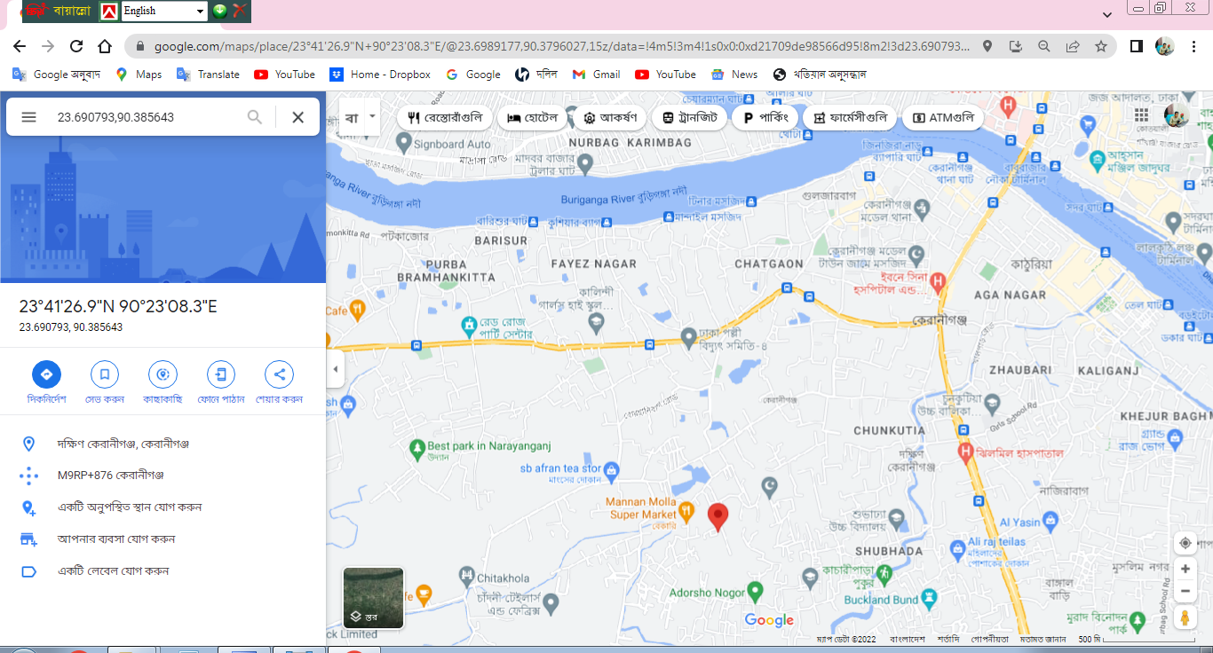
Google Map. (Google Code- 23.690793,90.385643)

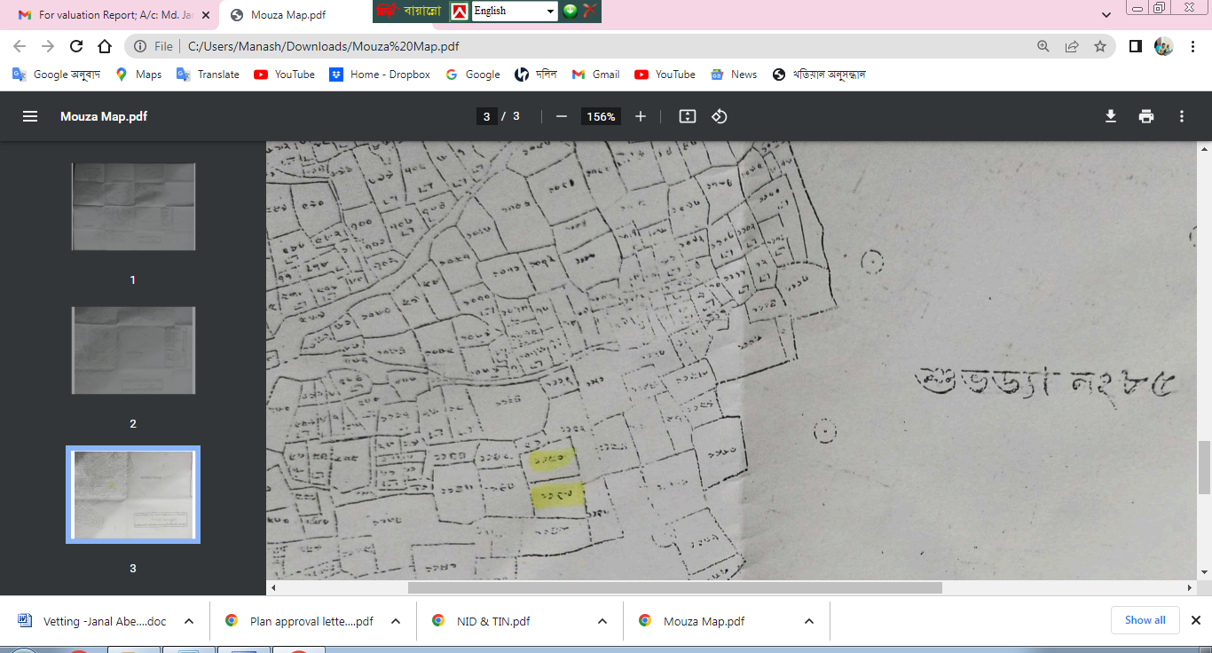
Mouza Map (R.S. Dag-1149, 1150.)

